**Experiment 4**

List out the required processes to be coded along with the required flow charts.

**1.Login**

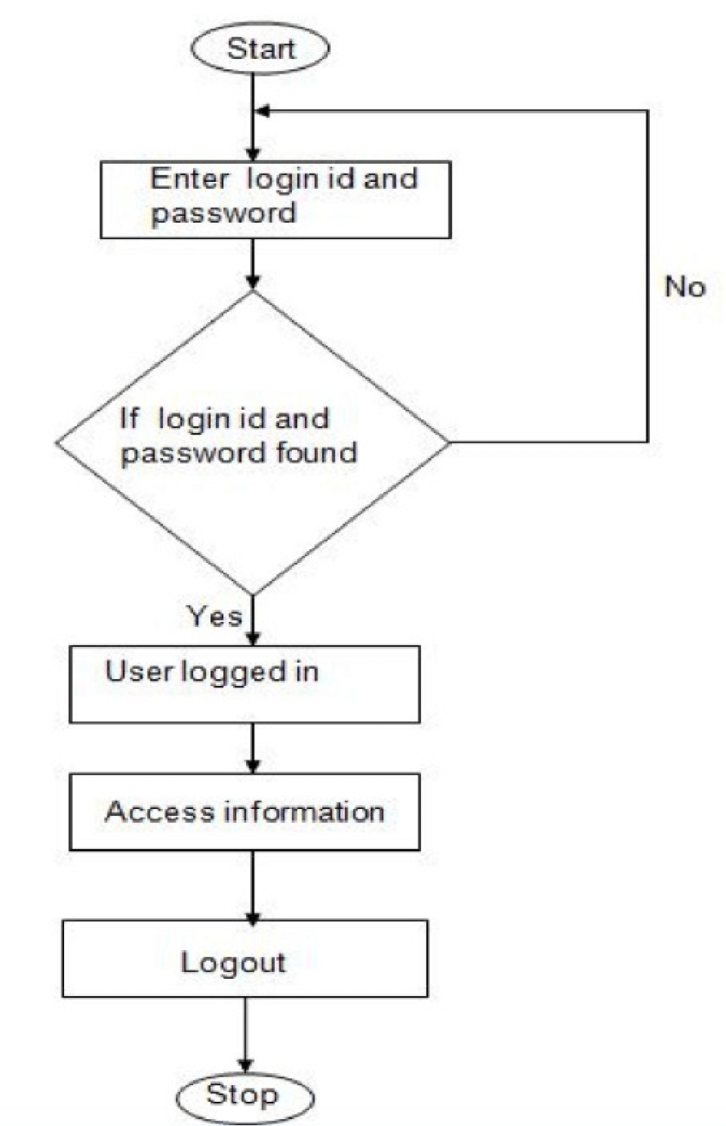

**2.Registration**

